

**Storm Drain Marking**

**Registration 2016**



Join us on Global Youth Service Day on **Saturday, April 16th from 9:00am-12:00pm**. The registration deadline is **April 6th**. An optional Global Youth Service Day Appreciation Picnic will be held at Toledo Zoo at 12:30pm after the project is complete.

Marking the storm drains reminds residents that storm drains flow directly to waterways without being treated and these drains are not trash receptacles. During this activity, participants will be asked to spray paint over a stencil near the storm drain and deliver informational door hangers to houses in residential areas. All equipment and training is provided. This activity is recommended for children above the age of 10; however, younger children are encouraged to participate with increased direct supervision. Liability forms are required for all participants. Please send registrations and questions to Partners for Clean Streams at PO Box 203 Perrysburg, OH 43552 or [Mike@PartnersforCleanStreams.org](mailto:Mike@PartnersforCleanStreams.org).

**Contact Name**________________________________________________________________________

**Address**____________________________________ **City**______________ **State**____ **Zip**___________

**Email Address**____________________________ **Phone number** _______________________________

**Organization/Troop/Pack # (if applicable)** _________________________________________________

**Does your group or leader have experience doing Storm Drain Marking previously? YES NO**

**Are you able to participate on the rain out date of April 30th if needed? YES NO**

**Will you be attending the Appreciation Picnic at the Toledo Zoo at 12:30pm? YES NO**

**Total number of youth participating** ______________

_____ 2nd-3rd grade ____4th-5th grade ____ 6th-8th grade _____9th-12th grade ____18 and older

After registration, we will send you your location assignment and more details. Please mark your top two preferences for which jurisdiction you would like to stencil in:

____ City of Waterville ____ City of Sylvania ____ Lucas County

____ City of Oregon ____ Village of Ottawa Hills ____ No preference

We will assign groups to jurisdictions depending on your preference, jurisdiction needs, size of groups, number of basins to stencil, and ages of participants. Because the activity is restricted by wet pavement or very cold conditions, the event may need to be postponed due to weather. The rain out date for Storm Drain Marking, independent of Global Youth Service Day, is **Saturday April 30th**. It is your responsibility to make up the event if canceled due to weather. Even if weather does not permit marking drains that day, groups might be asked to clean trash from around a parking lot, park or nearby school to prevent trash from entering the river via storm drains.

**Please bring, at least, one adult for every 4 youth participating.**

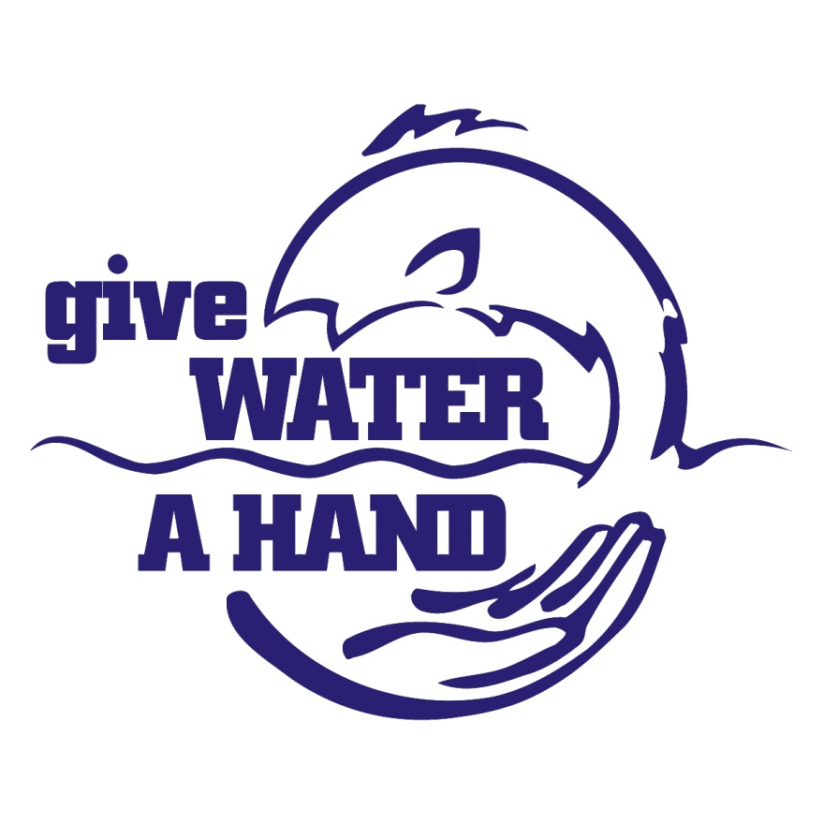

* Stencil a painted message or glue a medallion to remind residents that storm drains lead straight to waterways taking untreated pollution with it
* Groups are assigned to neighborhoods within local cities
* Ideal for children ages 10 and up wanting to make an impact in public education and water conservation efforts
* All training and equipment is provided
* Rain Date is April 30th, alternative scheduling possible
* Pre-registration is required by April 6th, contact PCS to register at

419-874-0727 or Mike@PartnersforCleanStreams.org

Marking the phrase

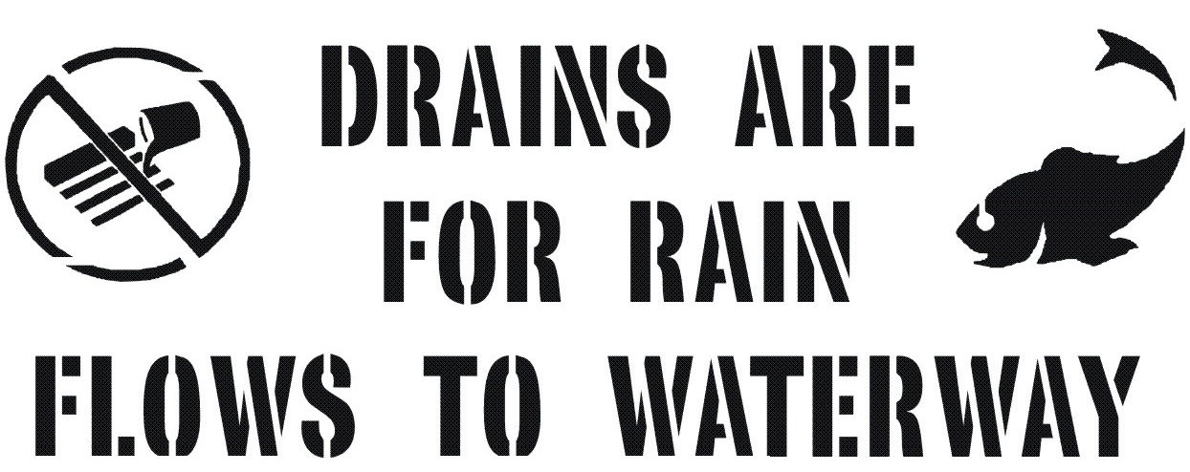

reminds people that anything entering a storm drains goes directly to the nearest waterway- No filters, No treatment!

**Protect our waterways**

by registering your group for

Storm Drain Marking.

Saturday, April 16th, 2016

9:00am-12:00pm

Marking locations vary

Global Youth Service Day Appreciation Picnic at

The Toledo Zoo at 12:30pm

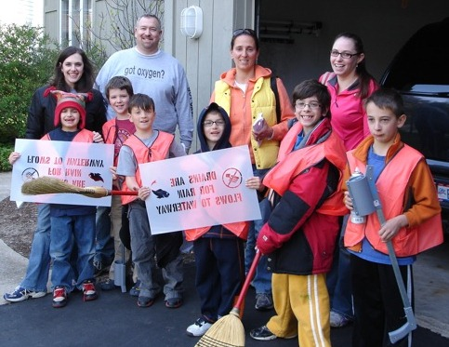

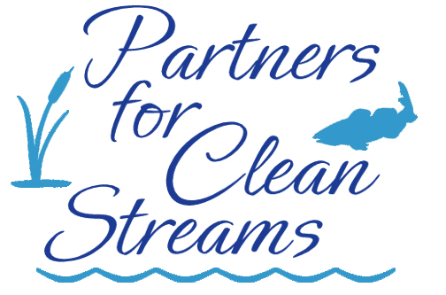

**Partners for Clean Streams**

**is proud to join**

**Global Youth Service Day with**

**Storm Drain Marking**